**Project current scenario-**

Cross border transaction is actually a very lengthy, taxed and time consuming process, which is why blockchain technology is very helpful in making safe, secure and fast money transfers between different accounts in different fiat currencies.

Cross-border payments using blockchain technology leverage the decentralized and secure nature of the blockchain to facilitate transactions between parties in different countries and using different currencies.

Several successful projects are done in this direction only. Specialized networks, such as Ripple and Stellar, provide services for frictionless high-value institutional settlements with the benefits of speed, automation, secure transactions and access to new markets.

Pros.

* Near real-time processing: Today, blockchain cross-border transactions have four to six seconds of the average velocity of money on a 24/7 basis and without intermediaries.
* Low-cost: Removal of intermediaries and better scaling solutions have allowed for transaction costs to be drastically reduced on blockchain transfers. However, gas fees vary as per demand and supply and market dynamics.
* Automated record-keeping: The immutable blockchain ledger technology enables transparency and verifiable records as all payment transactions and relevant data are automatically timestamped and recorded.
* Secure: Public-private cryptography, data hashing, multi-party authorization and fraud detection smart-contract enablers provide security in cross-border transactions.

Cons.

* Technology is complex to understand and master the code writing.
* High volume of data handling is yet to be tested.

**Why Fabric?**

Hyperledger Fabric is chosen for cross-border transaction systems because it provides a secure, flexible, and scalable platform for fund transfers. With its permissioned network, only trusted participants can join, reducing the risk of unauthorized access or manipulation. Hyperledger Fabric's robust security features and encryption mechanisms protect the integrity and confidentiality of accounts and balances. The immutability of the blockchain ledger guarantees that transactions records cannot be altered or deleted, providing a transparent and verifiable audit trail. Additionally, Hyperledger Fabric's scalability enables the system to handle a large volume of transactions ensuring efficient and reliable transfers.

**Working, organizations and blocks creation**

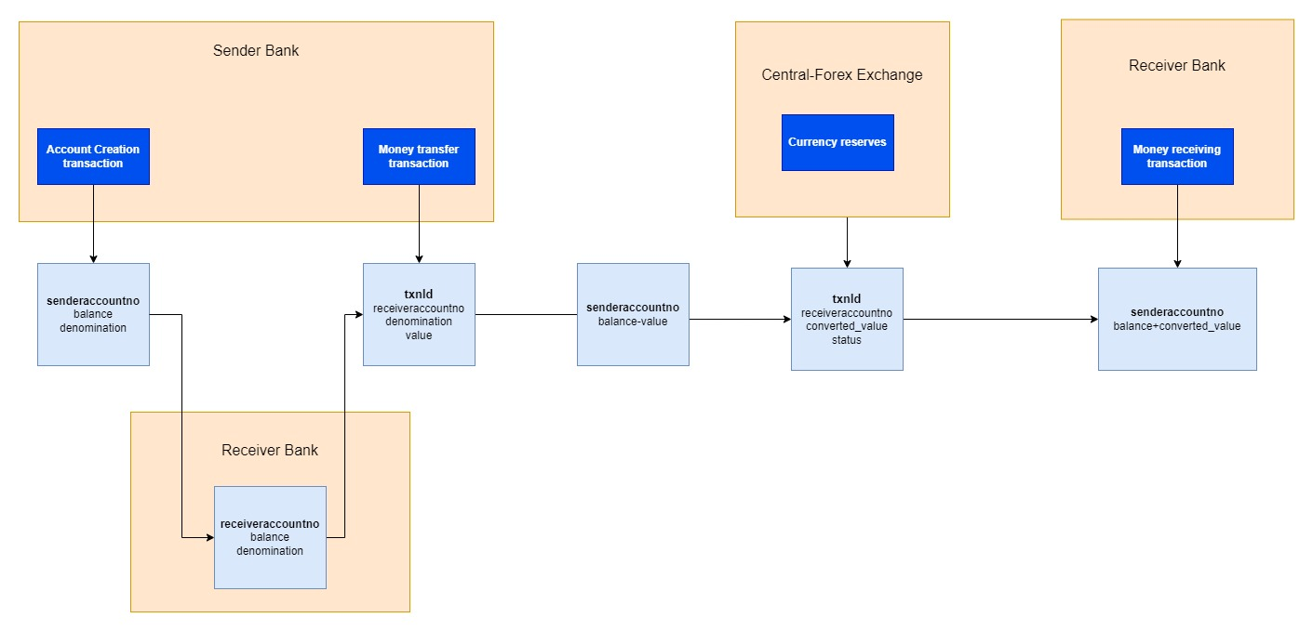

In the diagram, blue boxes are blocks of blockchain, which are created by organizations in the yellow boxes.

**Brief transaction flow and blocks creation-**

In the project, I assumed the banks to be in relation and, may be perhaps the nostro and vostro accounts. There are three organizations, sender bank, receiver bank, and central forex bank.

The sender and receiver bank create their respective accounts with accountno, balance and denomination. I have made private data collection(pdc) for senderbank and non pdc for receiverbank (but used access control only).

The moneytransfer transaction is added to ledger by senderbank only, with data of txnId, senderaccountno, receiveraccountno, value. This function successfully deducts the amount of transfer from sender’s account.

The approvetransaction function is accessed by centralforexbank organization only. It will convert the value to respective denomination of receiverbank account. And it will change status to true, if transaction is to be performed.

The receivetransaction function, is accessed by receiverbank organization only. It will fetch the converted_value from the previous transaction from its txnId. Only if status is true, given by centralforexbank, it will update balance of the receiver account.

Smart Contract functions-

1. CRUD operations on sender bank account, to be performed by Senderbank organization only.
2. CRUD operations on receiver bank account, to be performed by Receiverbank organization only.
3. Money transfer request, to be created by senderbank only
4. Approve transaction, to be done by central forex bank only, which will change status to true. And perform the conversion of currency value, depending on some fixed rates defined there.
5. On basis of transaction id, receiver is instructed to update balance of receiver account.

**Screen shots of transactions creation from functions of Smart contract-**

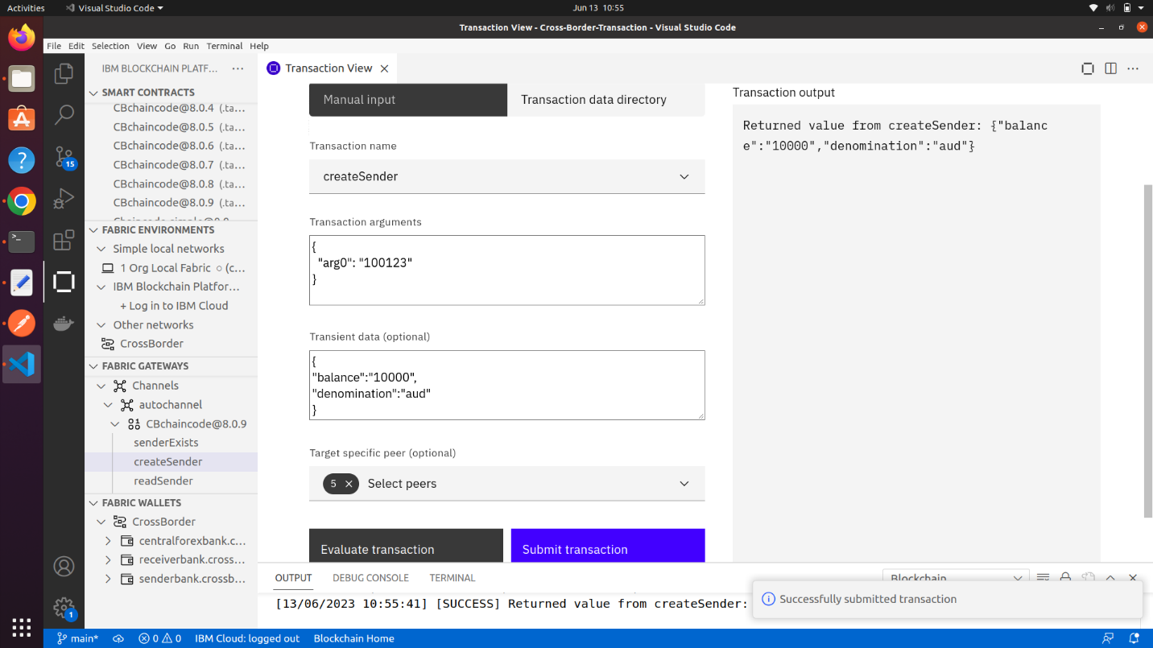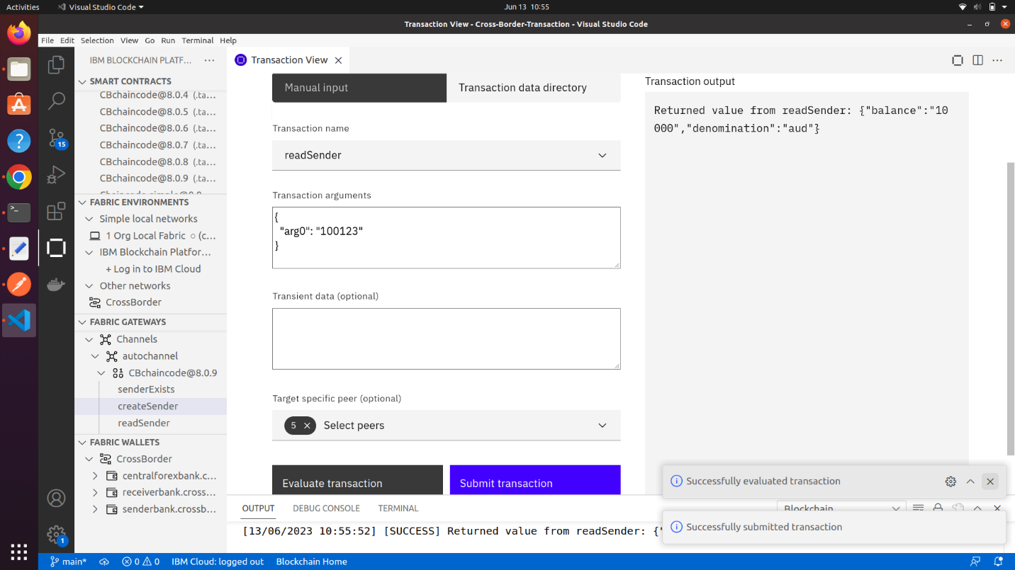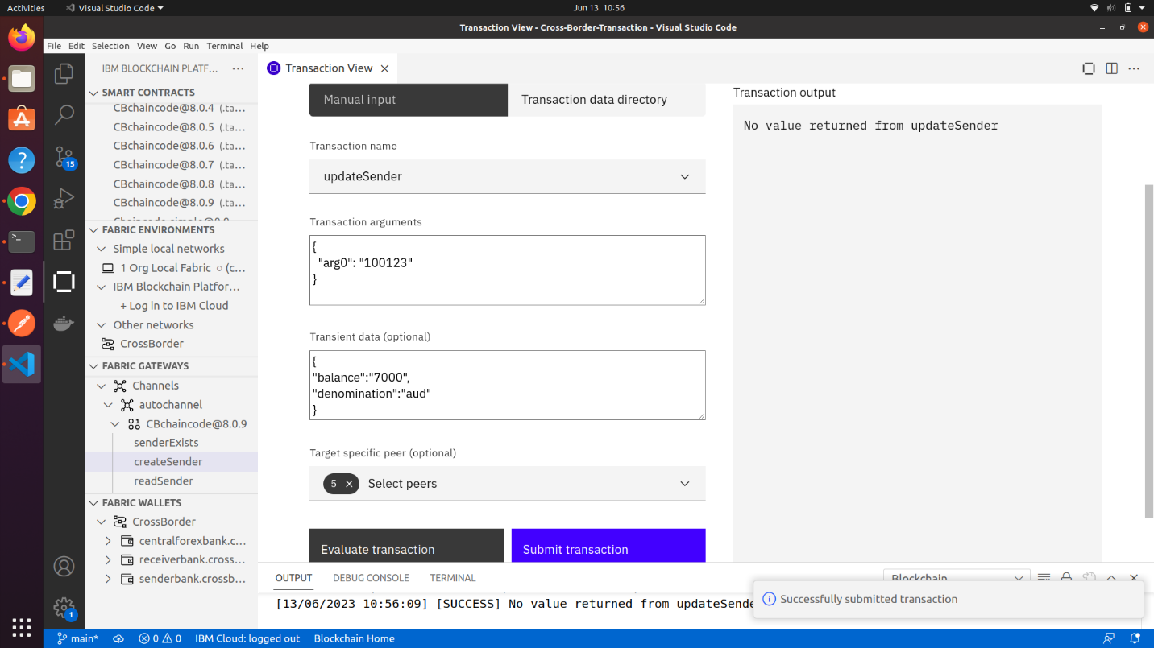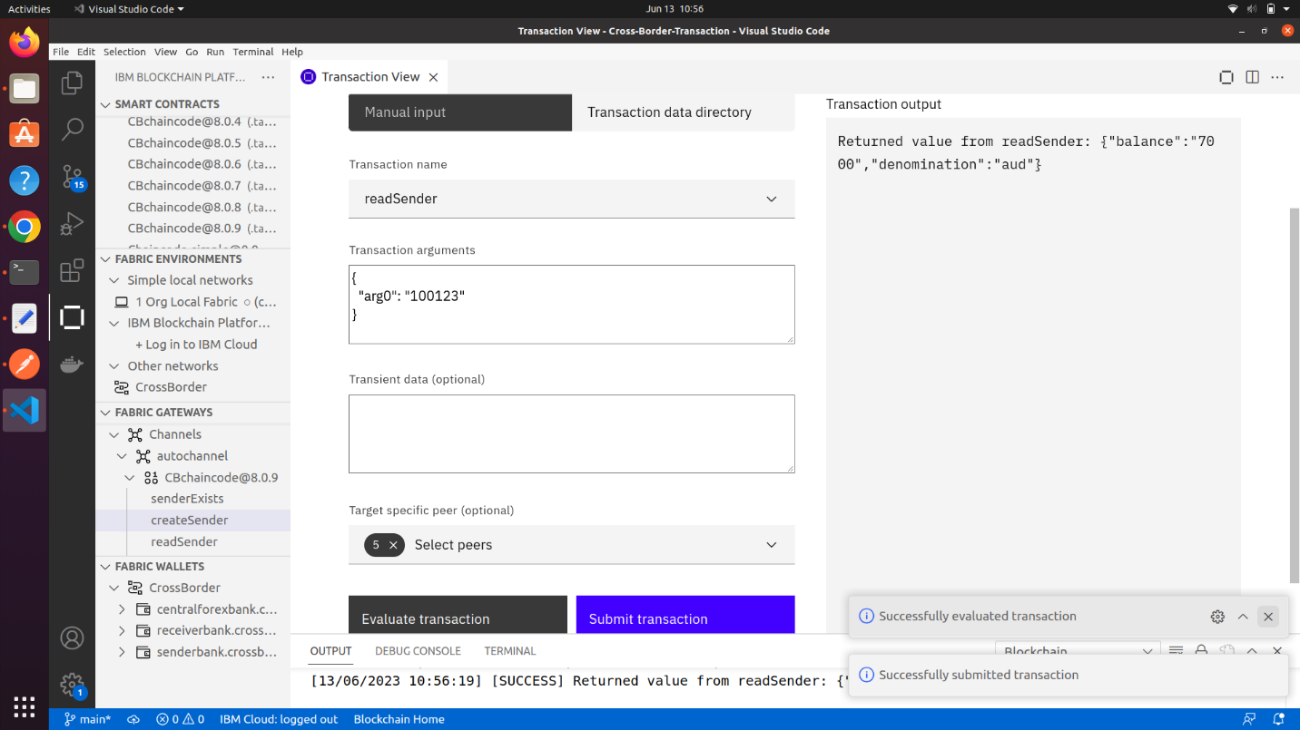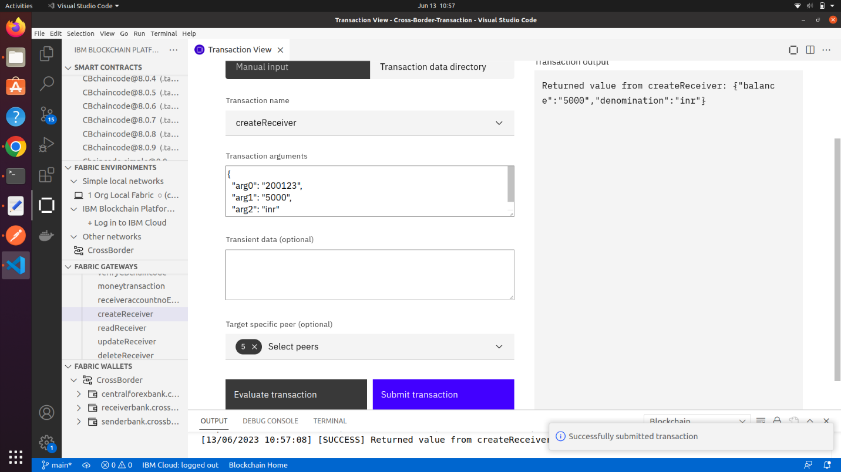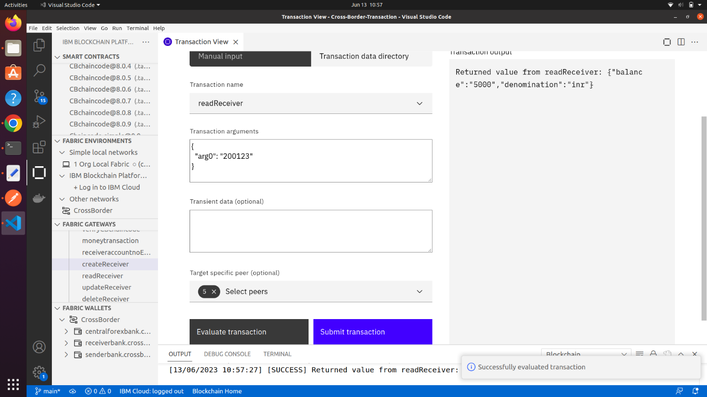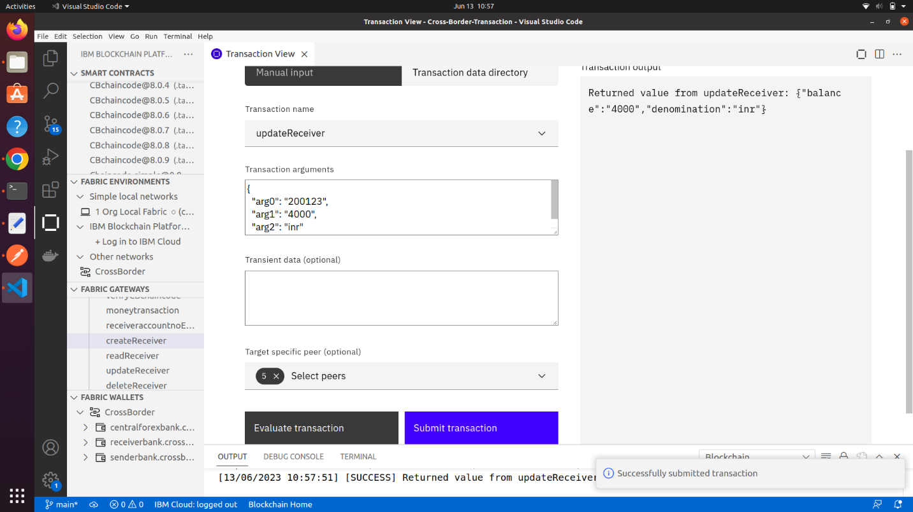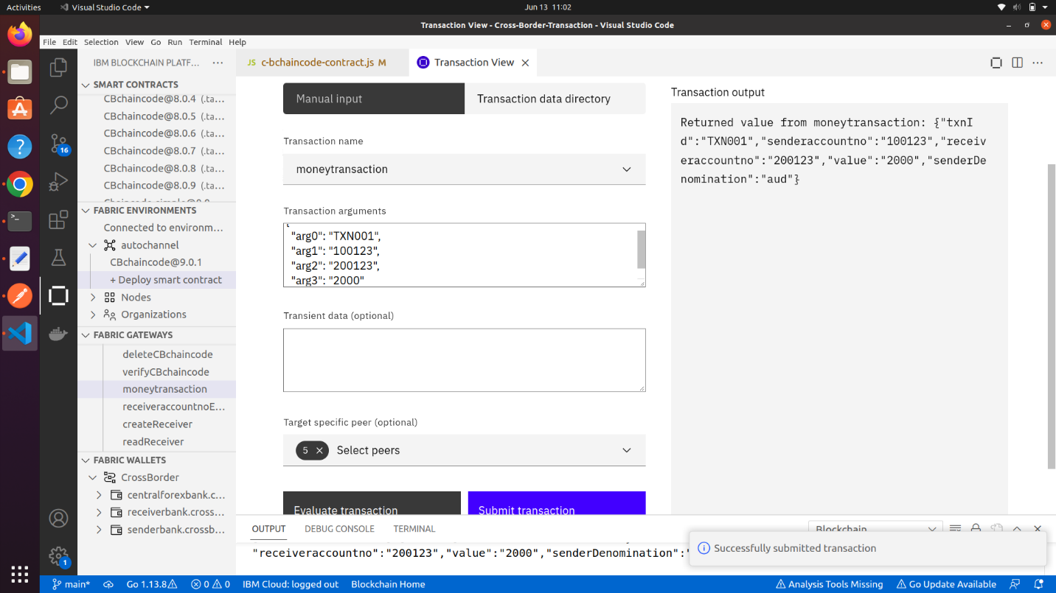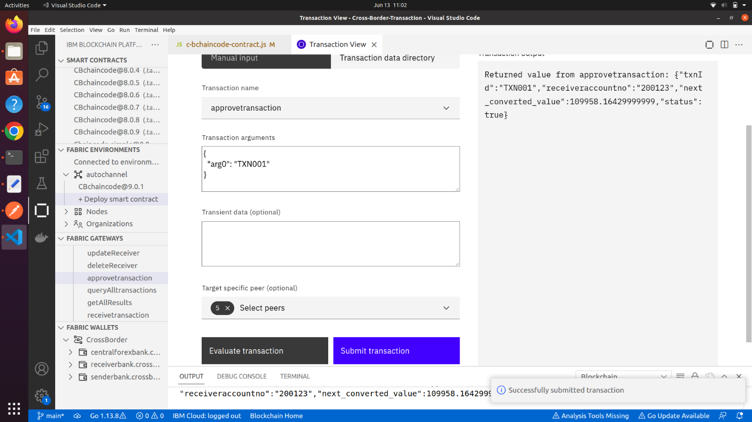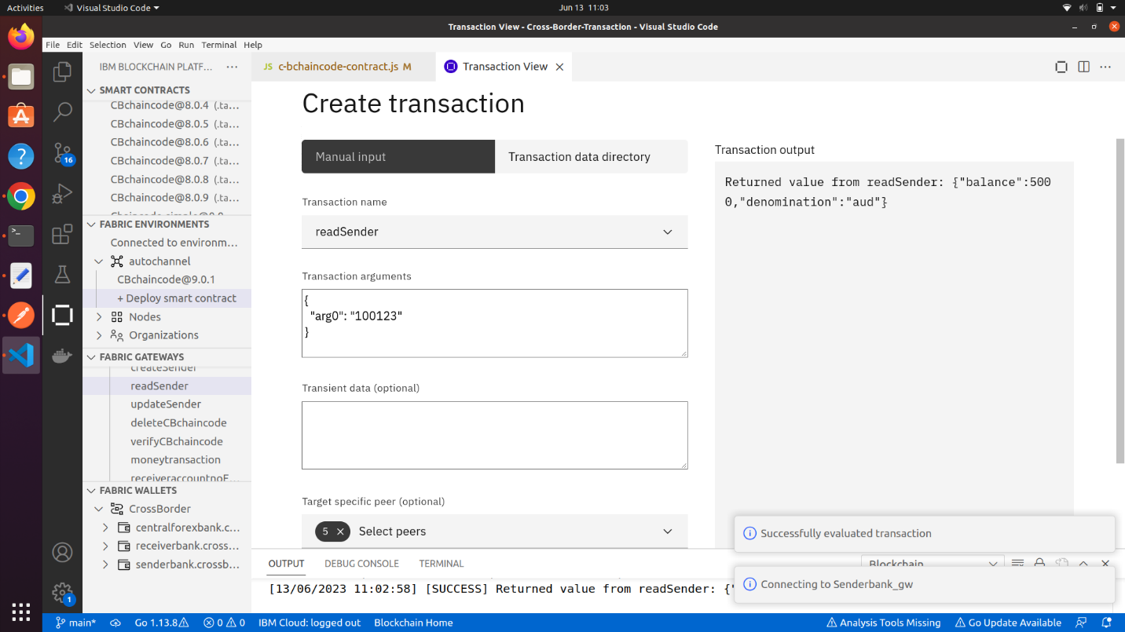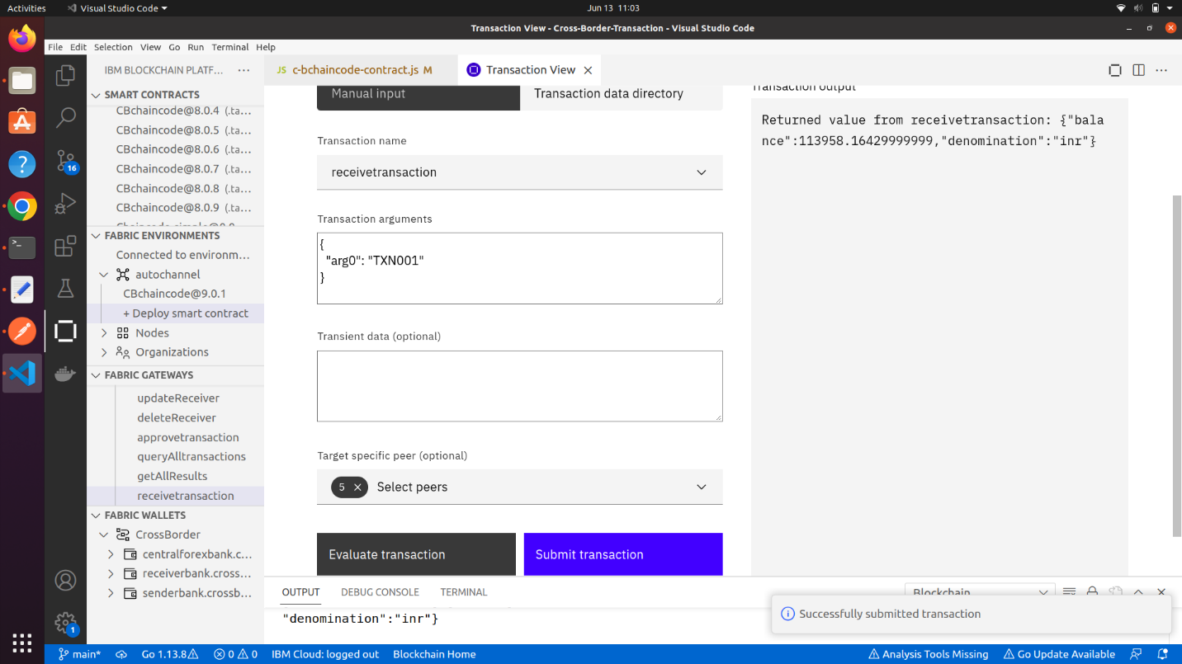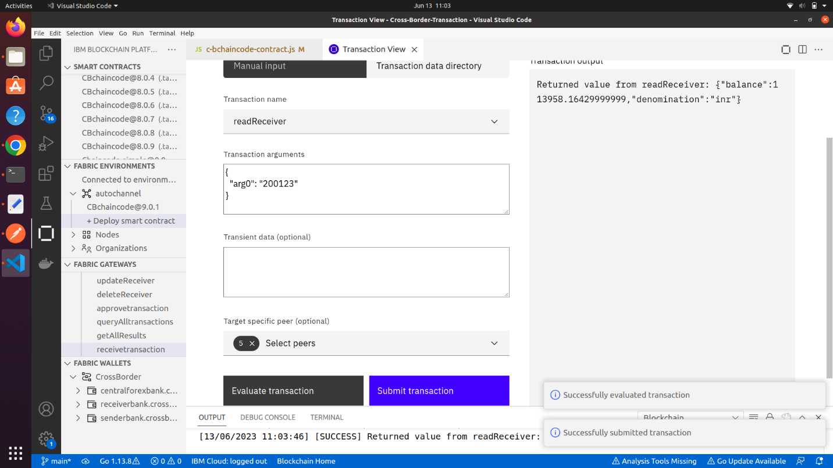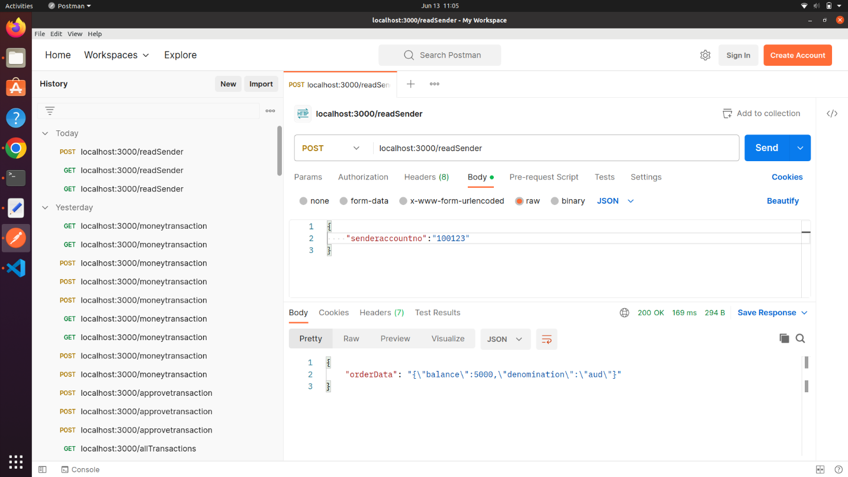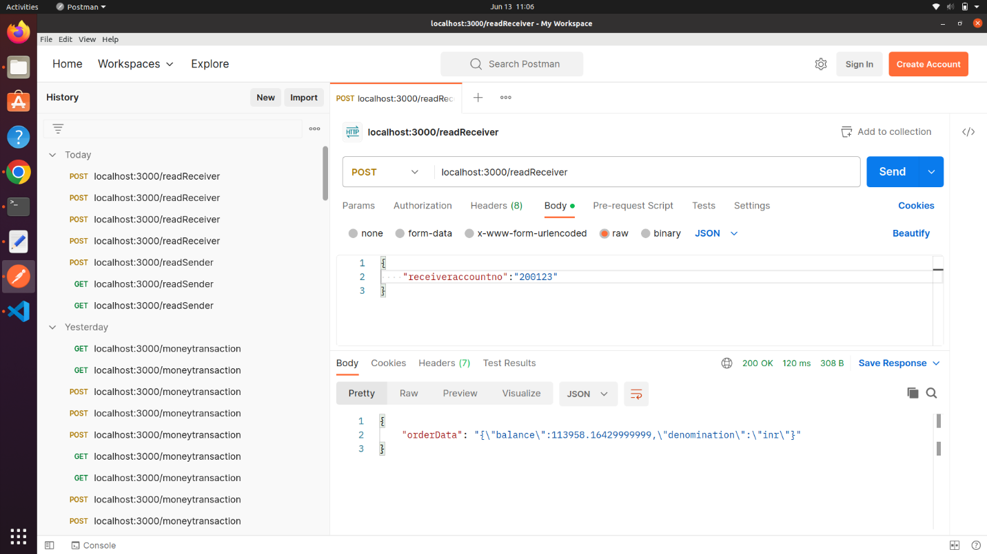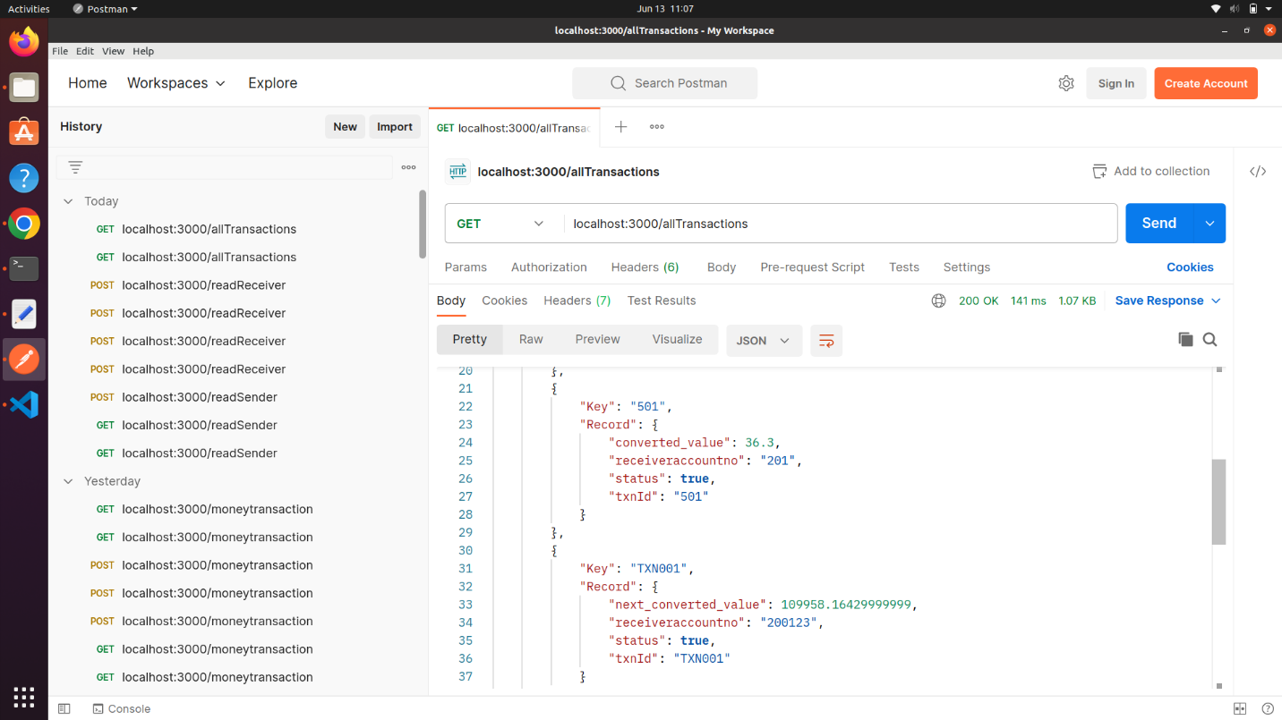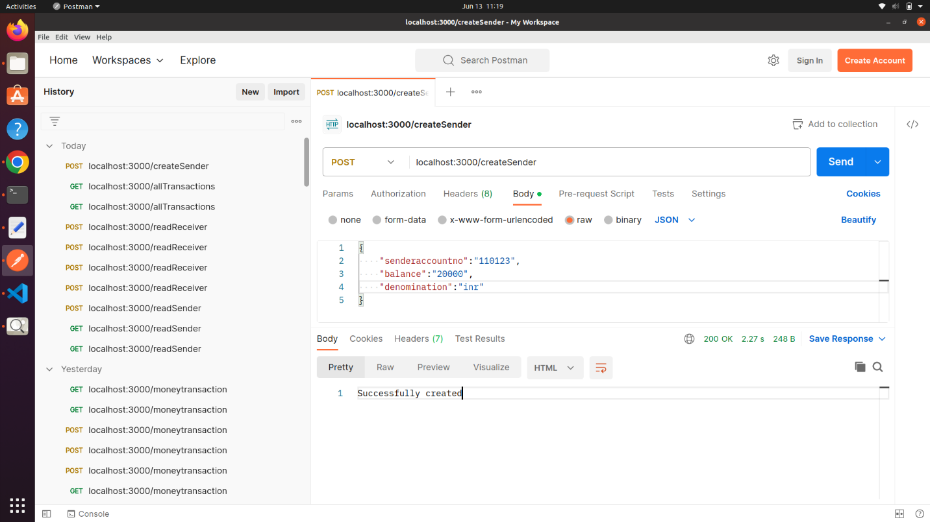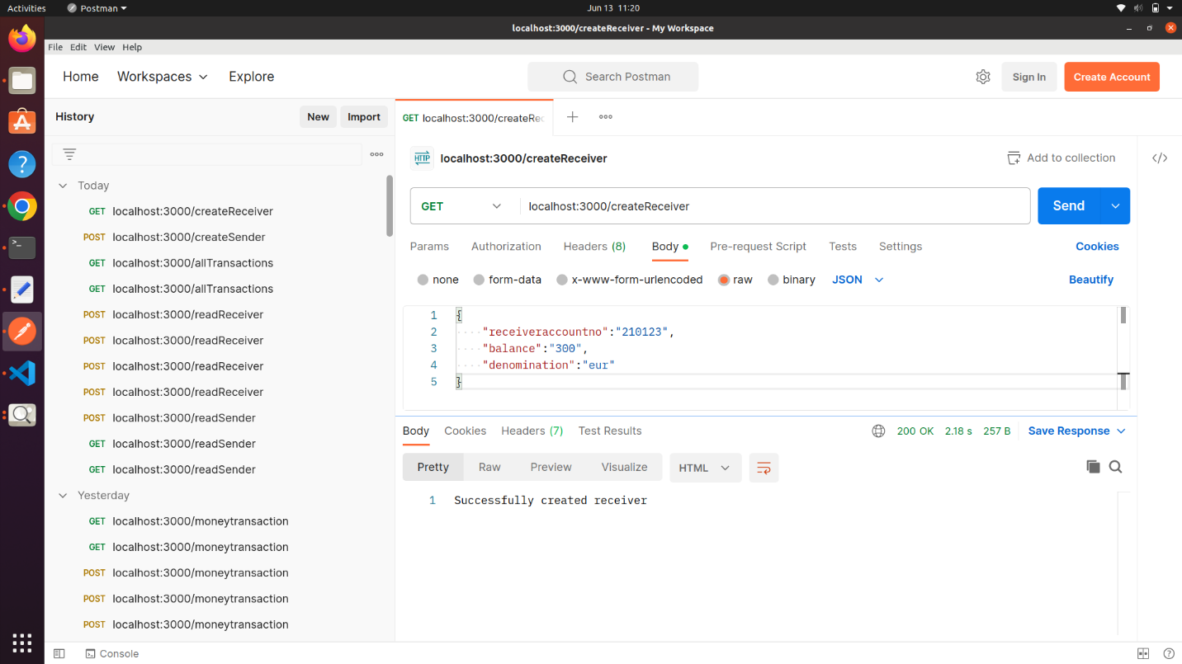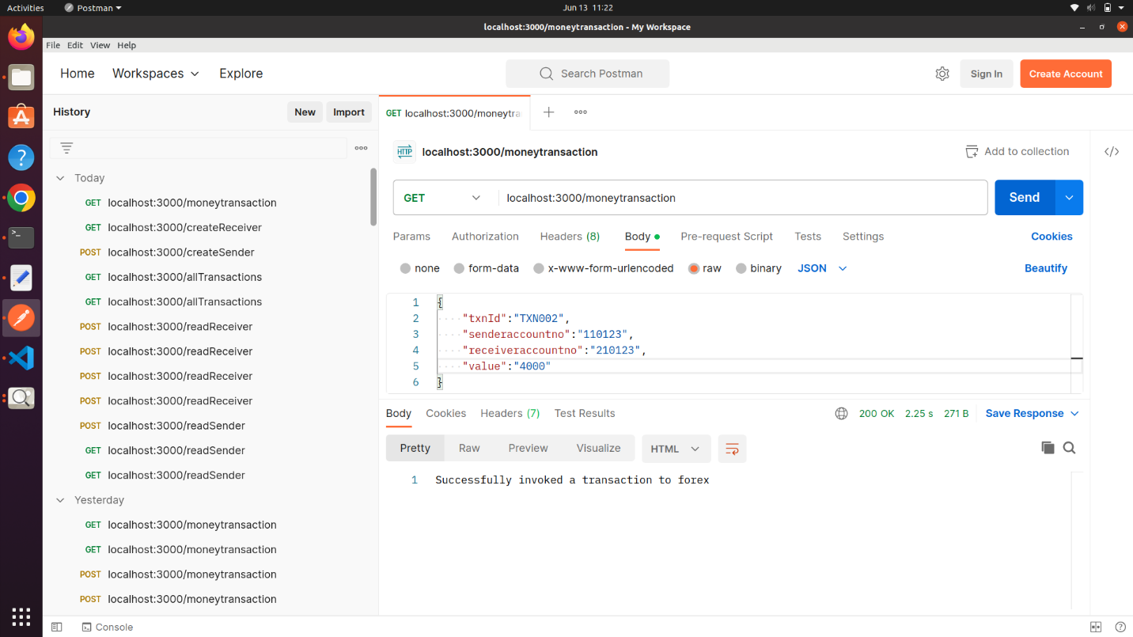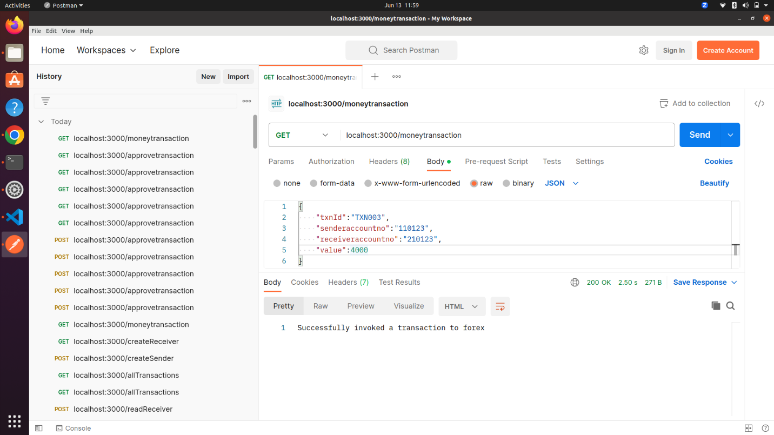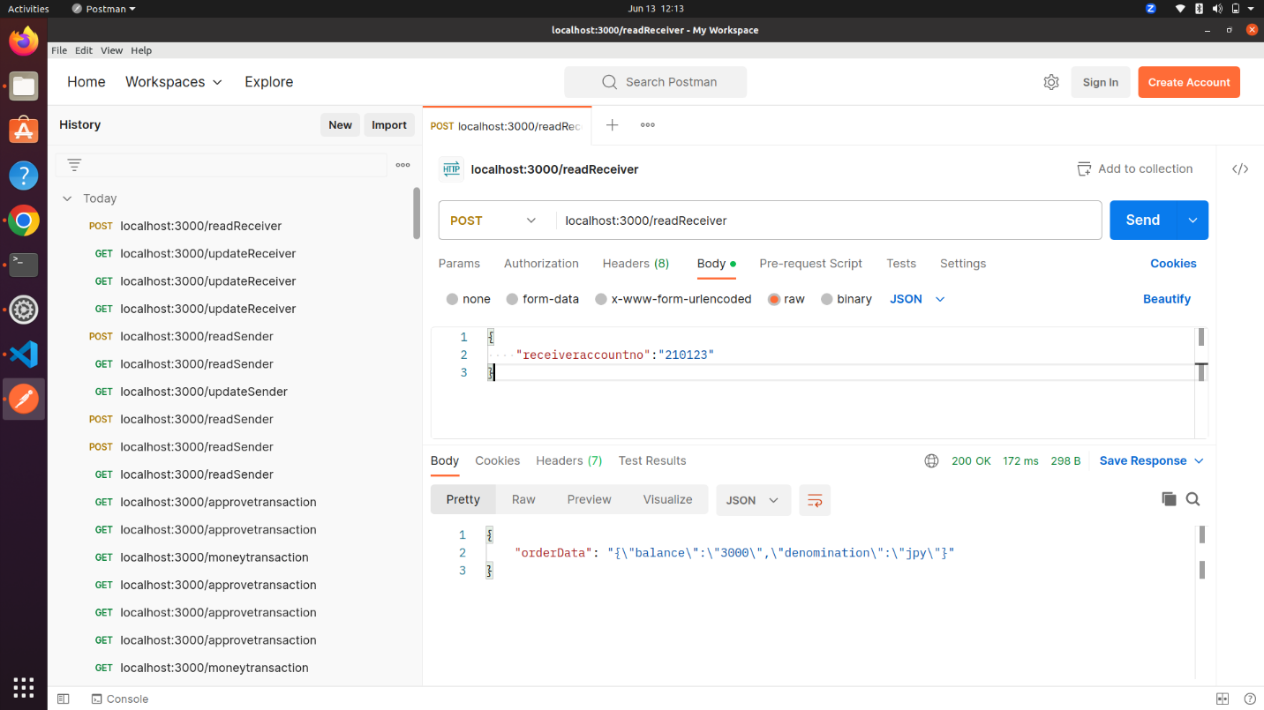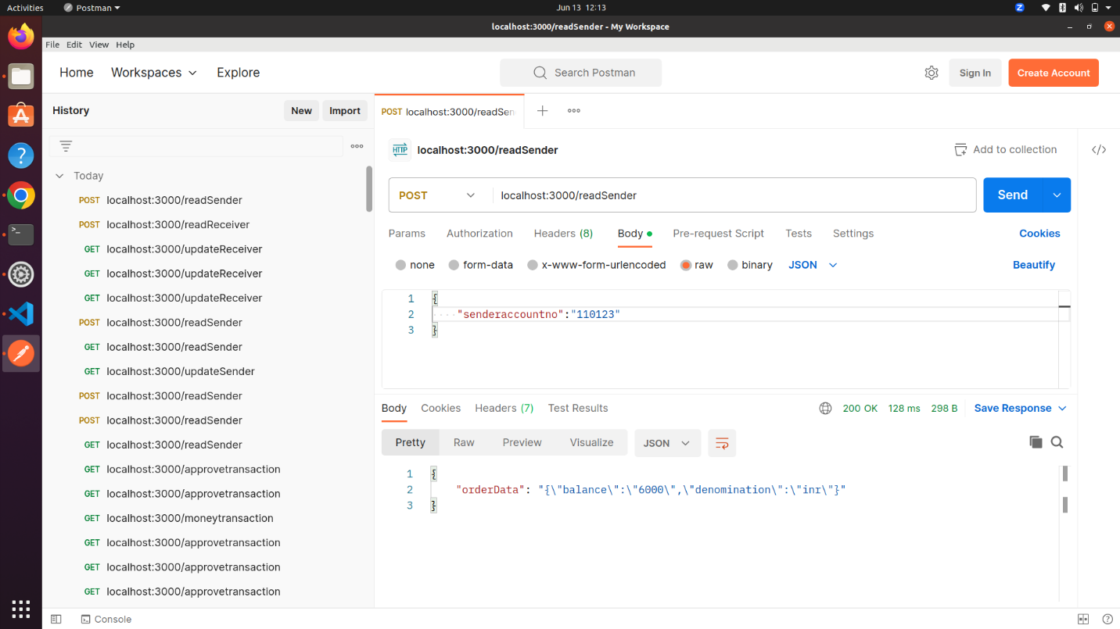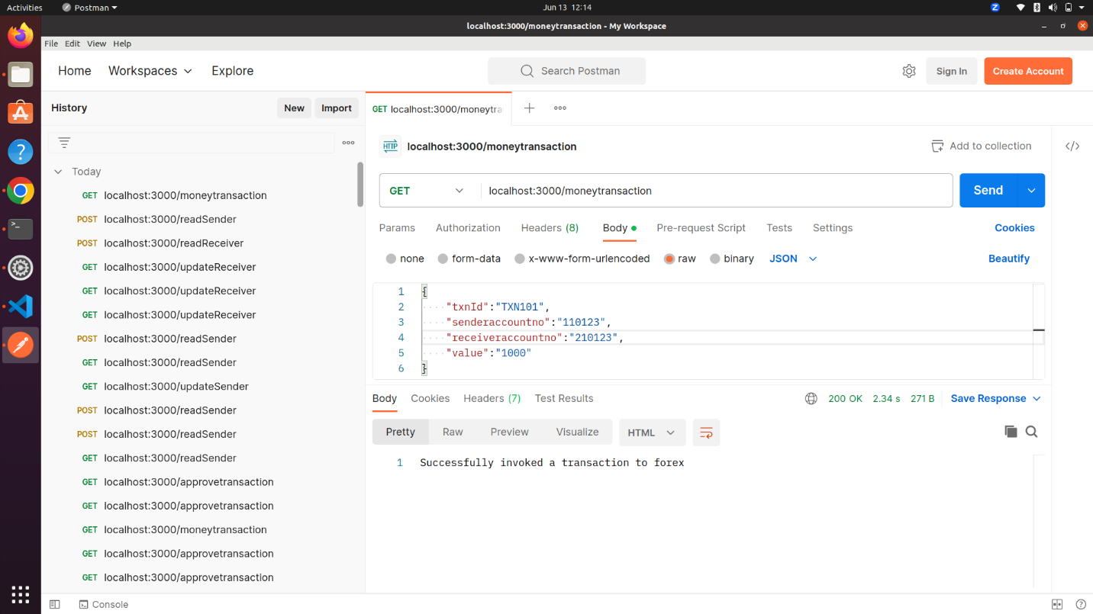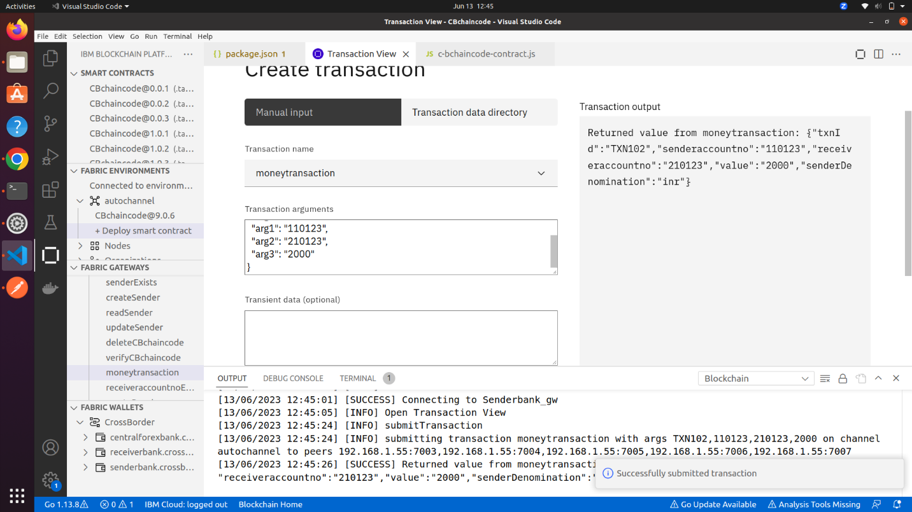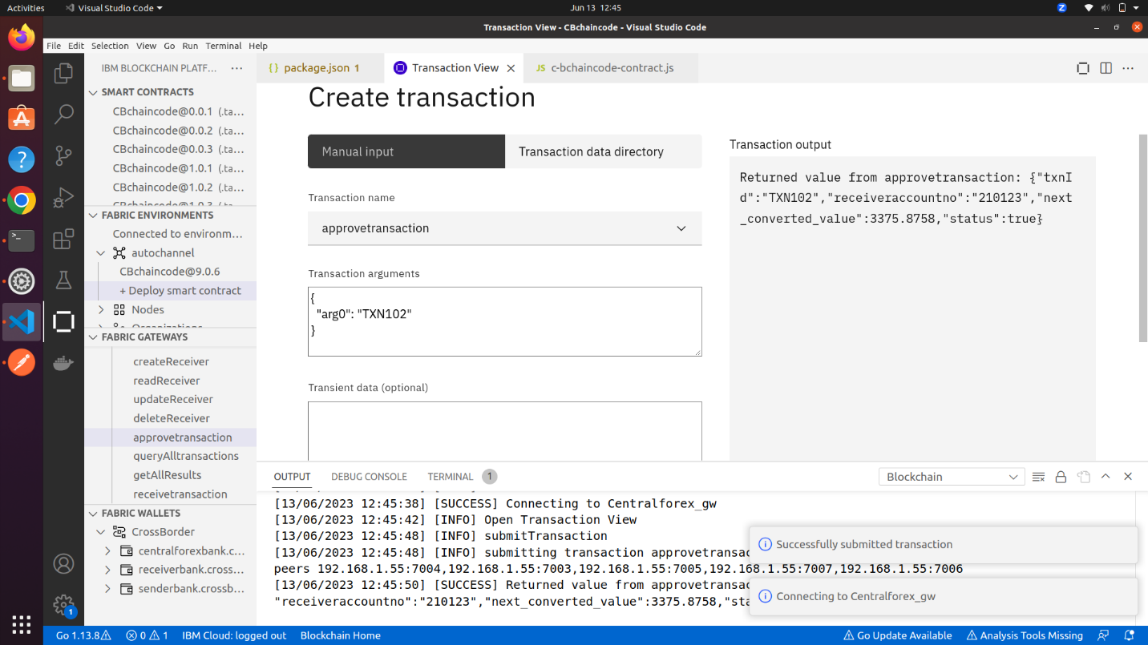

**Further improvements in the project-**

1. Changing rates in foreign exchange central bank would have been nice, which will fetch current rates only. Here in this project, rates were statically fixed.
2. Events to be followed, when status is false. Allowing capability of central bank to reject a money transfer request.
3. Inclusion of UI for better user experience.
4. Multiple banks intricacies, for better view of complex management.